UN-ROOFING A MYOCARDIAL BRIDGE
S. Mok, D. Majdalany, C. Pettersson
Cleveland Clinic, Cleveland, OH, USA

Background: Myocardial bridge (MB) is defined as a segment of a coronary artery that takes an intra-myocardial course. The presence of MB has been observed in as many as 40%-80% of cases on autopsy, radio-graphically from 0.5% to 16.0%, and often asymptomatic. However, it has been associated with angina, coronary spasm, myocardial infarction, arrhythmias, syncope, sudden cardiac arrest and death. Conflicting opinions exist on the timing of surgical intervention for MB.
Methods: We present an unusual case of a young female, with prior aortic surgery, who had refractory chest pain despite optimal medical therapy. Stress testing revealed anterior ischemia. Cardiac catherization showed MB of the LAD with significant compromise of blood flow (FFR 0.75 with adenosine). We proceeded with surgery. Intra-operatively, we found an unusually long (10 cm) intra-myocardial segment of LAD which was managed by surgically un-roofing. Post procedure, our patient felt better. Repeat cardiac catheterization showed no further narrowing of LAD with FFR of 0.8 in its distal segment.
Discussion: MB is present mostly in female patients (74.5%), median age at 56.2 years old, and mostly involving the LAD (77.2%). Average length of MB is 21.85+/-16.10mm (range 5-70 mm). Our case is unique as the involved MB was 10 cm in length, the longest ever reported. Multiple imaging modality revealed significant coronary insufficiency, with subsequent clinical and radio-graphical improvement upon un-roofing of the culprit coronary vessel.
Conclusion: Management decision on MB remains controversial. This is a case of the longest symptomatic MB, with subsequent improvement post-un-roofing.

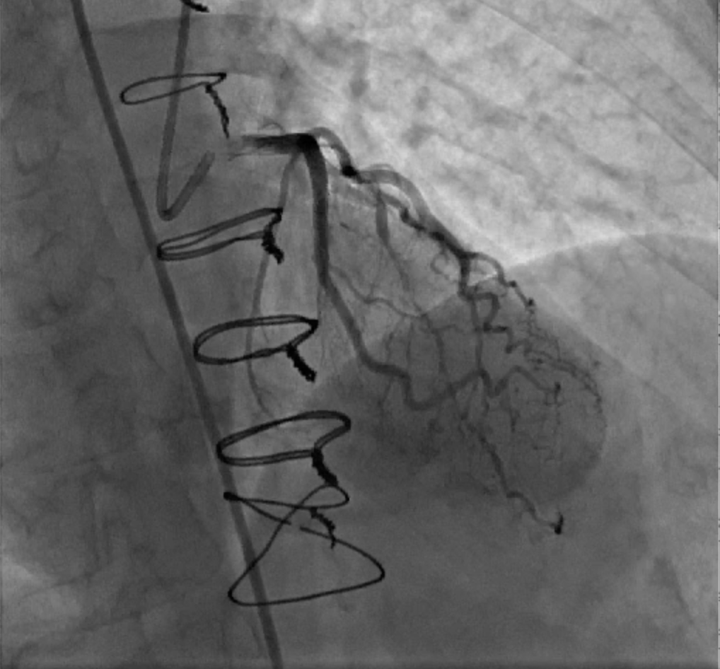
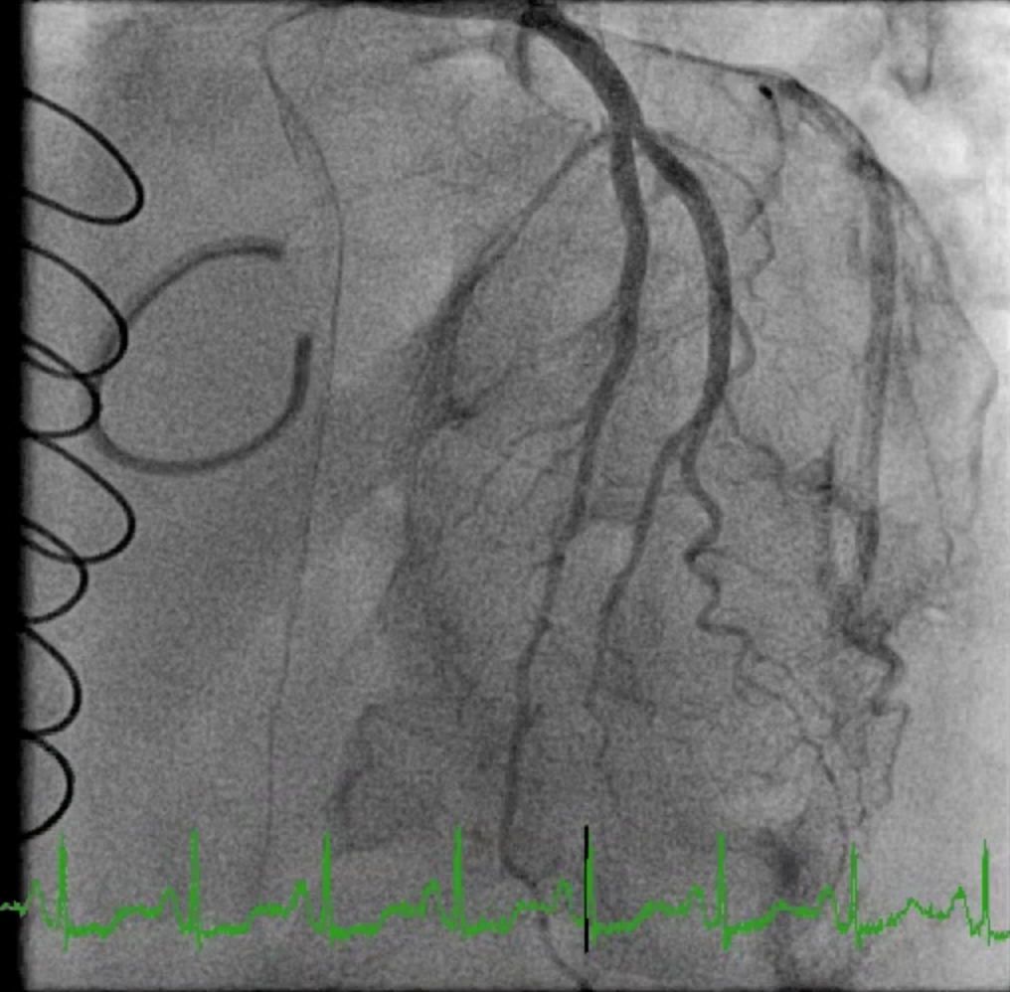
Post-operative cardiac catherization: patent LAD throughout the entire cardiac cycle (arrow).
Pre-operative cardiac catherization: severe LAD decompression during systole (arrow).

